Project Design Phase
Problem – Solution Fit Template

Date | 25/09/2026
Team ID | SWTID-2026-3184
Project Name | AI Study Buddy
Maximum Marks | 2 Marks

Problem – Solution Fit Template:
The Problem–Solution Fit for AI Study Buddy identifies the problems faced by students during their studies and provides an AI-based solution to address those problems. The project focuses on understanding students’ learning needs and providing personalized study assistance, practice, planning, and progress tracking through a single platform.
Purpose:
☐ Identify students’ learning problems and understand the difficulties they face while studying.
☐ Provide personalized AI-based assistance according to the student’s learning requirements.
☐ Improve study efficiency by providing study support, quizzes, and organized learning activities.
☐ Increase student engagement through interactive and personalized learning features.
☐ Understand the existing learning situation and improve the overall study experience for the target students.

Template:
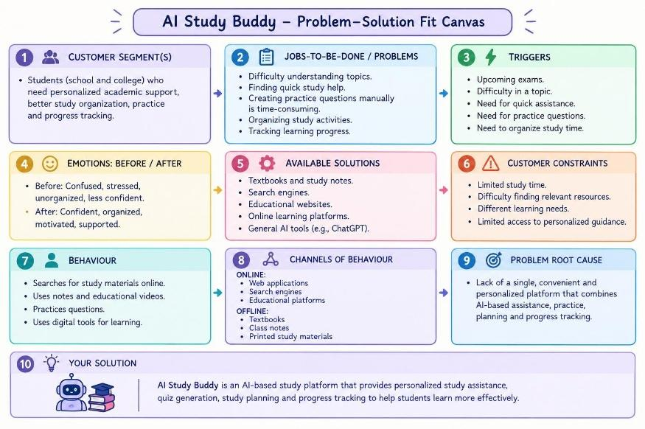

References:
- https://www.ideahackers.network/problem-solution-fit-canvas
- https://www.ideahackers.network/blog/problem-solution-fit-canvas-explained

